ID CARD PROCEDURES
FOR
PARENTS, PARENTS IN-LAW, STEP-PARENTS and PARENTS-BY-ADOPTION

Eligibility Criteria

Parents/parents in-law, step-parents and parents-by-adoption may be entitled to a DD Form 1173, Uniformed Service Identification and Privilege Card if they meet certain criteria:

a. They must be dependent on the sponsor for over 50 percent of their support.

b. They must reside in the sponsor's household or one maintained by the sponsor.

Documentation Required/Procedures

Sponsor must present a copy of his/her birth certificate or spouse's birth certificate (as applicable*) and a personal ID card each time an ID is issued.

ID card processing must be accomplished by the parent Armed Service. Cross servicing is not authorized, i.e., you may not apply to another branch of service. The sponsor and applicant forward their documents, along with a completed DD Form 1172, Application for Identification Card-DEERS, to the Defense Finance and Accounting Service: Indianapolis Center, DFAS-IN, Attn: Director of Military Personnel, Special Assistance Division, Dependency/Garnishment, 8899 East 56th Street Indianapolis, Indiana, 46249-0855. Upon approval, the sponsor will be provided a letter to take to the MPF for issue of the family member's ID card. NOTE: A new dependency determination is required each time an ID card is renewed.

benefits and privileges

If both dependency and residency are approved, the applicant will be entitled to medical care benefits in Uniformed Services Military Medical Treatment Facilities. The law does not authorize Civilian Health and Medical Program of the Uniformed Services (CHAMPUS) benefits for these family members. The applicant will also be entitled to commissary, Base Exchange and theater privileges.

If dependency is approved but not residency, the applicant will be entitled to Base Exchange and theater privileges only.

If only residency is approved, no ID card will be authorized.

* Verifying officials may request additional documentation to verify relationships and names. Marriage certificates, divorce decrees and birth certificates must be originals, court-certified copies, or photocopies that reflect the file number.

Hours of Operation

Legal Assistance
(Attorney consults by appointment only)
Mon-Thurs: By Appointment Only

Will Appointments
Please complete Will worksheet BEFORE you make a will appointment!
Wed: By Appointment Only

Powers of Attorney/Notaries
Mon-Thur 0900-1600
Fri 0900-1400
Closed every second Friday

You can complete power of attorney & will worksheets, and read information at https://aflegalassistance.law.af.mil

51 FW/JA
OPC 3 BOX 2067
APO AP 96266-2067
Building 938, Osan AB
DSN 784-4131 or commercial 0505-784-4131

ID CARD PROCEDURES
FOR PARENTS

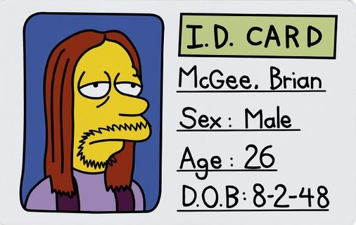

51st Fighter Wing

LEGAL OFFICE

Current as of August 2025

